**WIA/WIB 2003 – Probability and Statistics**

**TUTORIAL**

**DESCRIPTIVE STATISTICS and HYPOTHESIS TESTING**

1. The data below lists the number of times the students in a class were absent.

0, 2, 0, 1, 0, 0, 2, 0, 0, 0, 0, 2, 4, 4, 5, 1, 0, 2, 0, 0, 2, 2, 0

1. Identify the minimum, maximum, median, Q1 and Q2.
2. Calculate the mean and standard deviation.

2. Ten patients at a doctor’s surgery wait for the following lengths of times to see their

doctor.

5 mins 17 mins 8 mins 2 mins 55 mins

9 mins 22 mins 11mins 16 mins 5 mins

1. What are the **mean, median and mode for these data**?
2. What measure of central tendency would you use here?

3. For the following data sets, **calculate the quartiles and find the interquartile range**. The following numbers represent the time in minutes that twelve employees took to get to work on a particular day.

18 34 68 22 10 92 46 52 38 29 45 37

4. The table below gives the number of students in a given age range who commensed a Bachelor’s degree at the University of Sydney in 1997. The age is given in whole years and so, the range 20–24 includes those students who have had their twentieth birthday, and those who are 24 but have not yet turned 25. Thus, the class interval 20–24 is a 5 year interval.

Note also that the ‘Under 20’ and ‘45 and over’ classes are open ended. Decide on a reasonable lower end point and upper end point respectively and use them to draw histogram for these data.

**Draw a histogram to represent these data.**

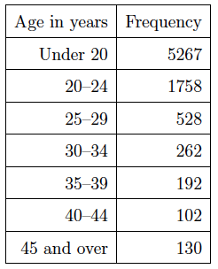

5. The following data set give the daytime temperature in Melbourne for February 1998.

**Draw a box-plot for the given data set.**

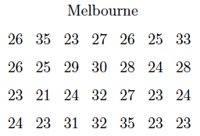

6. A principal at a certain school claims that the students in his school are above average intelligence. The mean population IQ is 100. **Express the null hypothesis H0 and alternative hypothesis H1 in a symbolic form.**